HW W5-2:

Name : Student ID:

1. A worker is tiling a road with n square grids, there are two different kinds of bricks available, one is the square brick and the other is the rectangle brick which covers 2 grids. Please count the total different ways the road can be tiled.

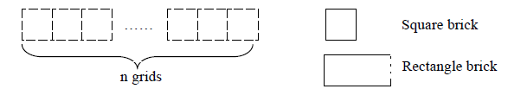

1. How many different ways to color n grids in a line with red, white or blue colors but no two adjacent grids are colored with red?